HMCS GLACE BAY – Day Sail (11th January 2024)
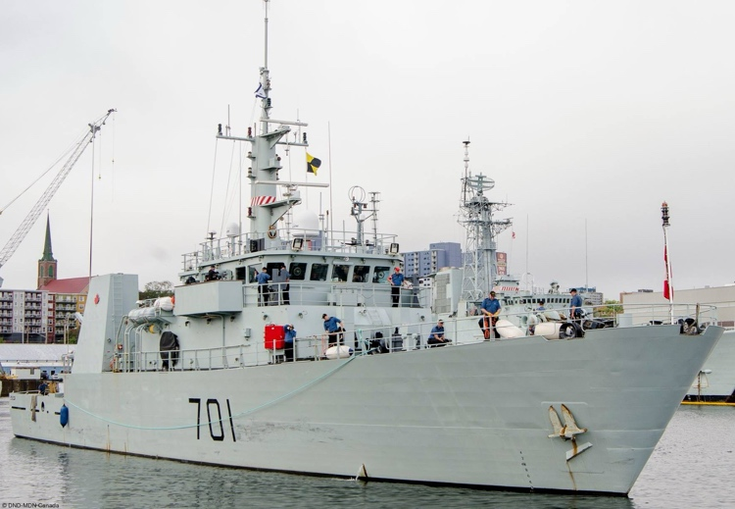
Exciting Opportunity Alert!! RCSCC Nelson is seeking cadets in Phase 2 or higher (over the age of 14) who are interested in applying for the chance to take part in a Day Sail onboard the Kingston-class patrol ship HMCS Glace Bay on January 11th. More details and application link below!

As part of their routine coastal deployments, the ship’s company of HMCS Glace Bay will be welcoming a selected group of sea cadets from multiple corps within HRM onboard for a day-long educational experience, to tour the ship and witness its operations. HMCS Glace Bay will depart HMC Dockyard (down the street from Scotian) on the morning of January 11th for operations off the coast of Halifax, and will return to Dockyard in the afternoon or evening of the same day (exact timings to be determined) – lunch will be provided on the ship. Adult staff officers from the cadet program will be present onboard to supervise. Cadets who take part would be expected to wear their C5 sea training uniform (with parka), and would need to arrange their own transportation to Dockyard.

Are you interested in applying for a spot on this exciting Day Sail trip? Fill out the form below, and if you meet all of the eligibility criteria in the form, Nelson staff will nominate you for a spot. The number of available spots per cadet corps is currently not confirmed, so we cannot guarantee a place on the trip for everyone who applies - however we encourage everyone who is interested to do so! If selected, you will be contacted by Nelson staff on or shortly after January 2nd, and will be required to complete a parental consent page to confirm your participation. Due to the nature of this trip, certain medical conditions may prevent participation - please see the form for those details.

The form to be nominated is at the link below! Any questions, please reach out to staff at 1sea@cadets.gc.ca. The nomination form closes at midnight on December 28th.

APPLY HERE: https://forms.office.com/r/04D6iKVUXN

